


XML Validator Installation Manual
Version 4.0

Step 1: Copy goAMLXValidator.exe, goAMLXValidator.exe.config, BD - goAMLSchema 4.0.xsd in a location of computer
Step 2: Double Click goAMLXValidator.exe and find the screen as follows

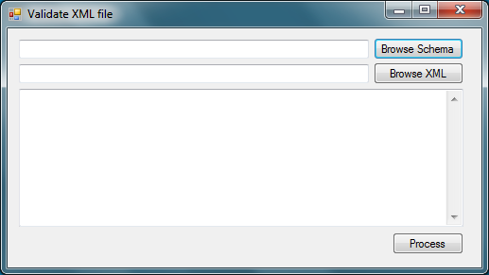

Step 3:Click “Browse Schema” Button and select “BD - goAMLSchema 4.0.xsd” (Schema of goAML)

Step 4: Click “Browse XML” button and select appropriate XML and you get following screen

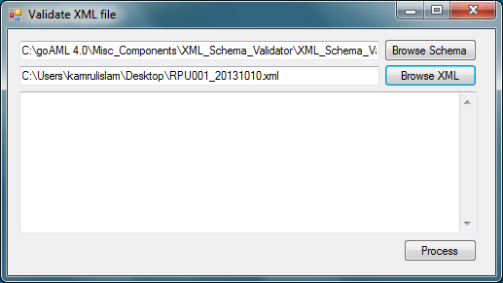

Step 5: Click “Process” Button

Step 6: If there are errors in schema a list of errors will be shown with ‘File has been processed!’ as below or if no errors found then only “File has been processed! message will be shown. Click “OK” .

